Lab Report-4

(Sanchit jalan,Group-3,2022101070,Table No:-40)

Experiment 4:-

To design an Arithmetic and Logic Unit (ALU) capable of performing 8 Arith- metic/Logic functions on 1-bit operands

Electronic components Required:-

1. Digital test kit
2. Wires
3. 2 Multiplexer (8:1)
4. 1 Multiplexer (2:1)
5. XOR gate
6. Arduino UNO

8:1 MUX and 2:1 MUX Input Table:-

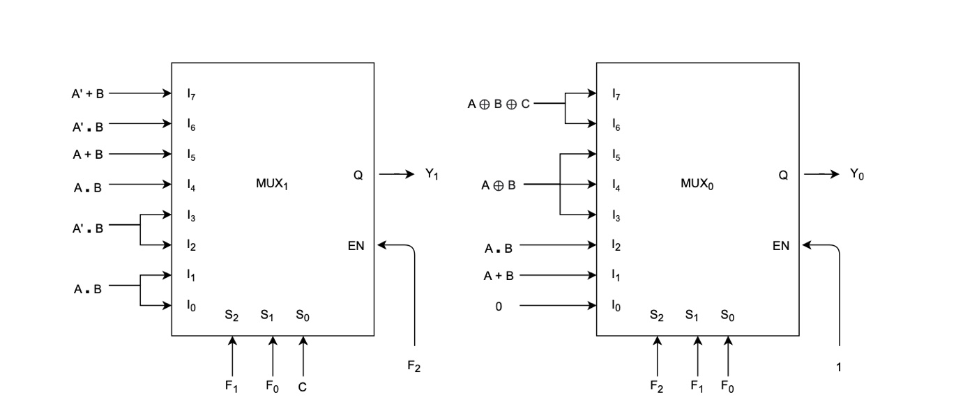

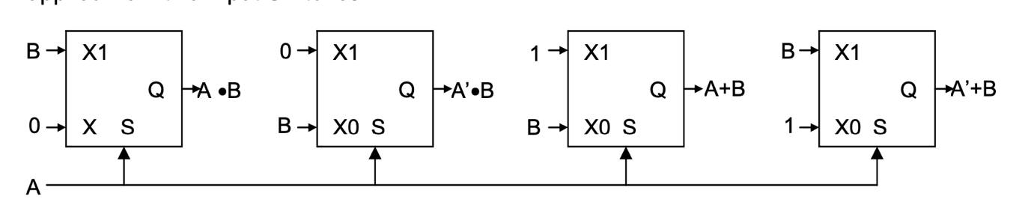

TinkerCAD simulation:-

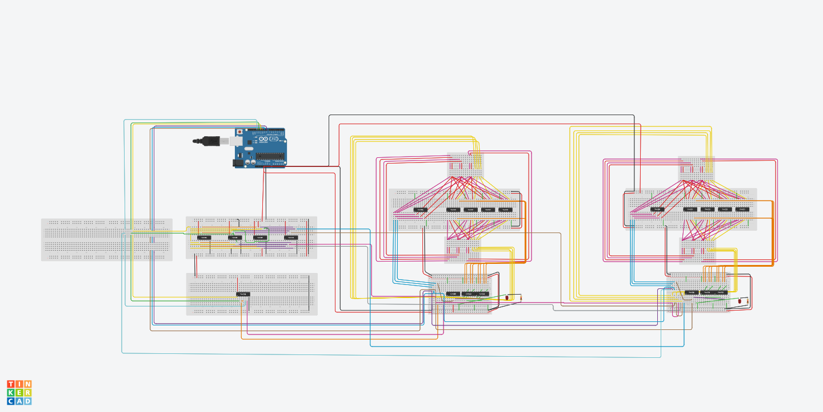

Procedure:-

1. Connect the Arduino UNO to your pc using USB.
2. Take 2:1 MUX and input A as select line and design the input of the 2:1 MUXs as shown in the image above.
3. The above step will generate various functions of A+B, A.B, A’.B, A’+B..
4. To generate A ⊕ B and A⊕ B⊕ C take 7486 IC and put appropriate inputs and obtain outputs.
5. Take 8:1 MUX and S0,S1,S2 as select lines and design the inputs of 8:1 MUXs as shown in the image above.
6. In my tinkerCAD simulation :-

|  |  |
| --- | --- |
| ARDUINO PIN | VALUE |
| 8 | S0 |
| 9 | S1 |
| 10 | S2 |
| 11 | A |
| 12 | B |
| 13 | C |

Arduino Code:-

int a=11;

int b=12;

int c=13;

int s0=8;

int s1=9;

int s2=10;

int x;

int y;

int z;

int t;

int u;

int v;

void setup()

{

pinMode(s0, OUTPUT);

pinMode(s1, OUTPUT);

pinMode(s2, OUTPUT);

pinMode(a, OUTPUT);

pinMode(b, OUTPUT);

pinMode(c, OUTPUT);

Serial.begin(9600);

}

void loop()

{

Serial.print("S0= ");

while (Serial.available()==0){}

x=Serial.parseInt();

Serial.println(x);

Serial.print("S1= ");

while (Serial.available()==0){}

y=Serial.parseInt();

Serial.println(y);

Serial.print("S2= ");

while (Serial.available()==0){}

z=Serial.parseInt();

Serial.println(z);

Serial.print("a= ");

while (Serial.available()==0){}

t=Serial.parseInt();

Serial.println(t);

Serial.print("b= ");

while (Serial.available()==0){}

u=Serial.parseInt();

Serial.println(u);

Serial.print("c= ");

while (Serial.available()==0){}

v=Serial.parseInt();

Serial.println(v);

digitalWrite(s0,x);

digitalWrite(s1,y);

digitalWrite(s2,z);

digitalWrite(a,t);

digitalWrite(b,u);

digitalWrite(c,v);

delay(1000);}

Observation Table:-

|  |  |  |  |  |  |
| --- | --- | --- | --- | --- | --- |
| FUNCTION | S0 | S1 | S2 | Y0 | Y1 |
| ZERO | 0 | 0 | 0 | 0 | - |
| A or B | 1 | 0 | 0 | |  |  |  | | --- | --- | --- | | A | B | Y0 | | 0 | 0 | 0 | | 0 | 1 | 1 | | 1 | 0 | 1 | | 1 | 1 | 1 | | - |
| A and B | 0 | 1 | 0 | |  |  |  | | --- | --- | --- | | A | B | Y0 | | 0 | 0 | 0 | | 0 | 1 | 0 | | 1 | 0 | 0 | | 1 | 1 | 1 | | - |
| A exor B | 1 | 1 | 0 | |  |  |  | | --- | --- | --- | | A | B | Y0 | | 0 | 0 | 0 | | 0 | 1 | 1 | | 1 | 0 | 1 | | 1 | 1 | 0 | | - |
| A plus B | 0 | 0 | 1 | |  |  |  |  | | --- | --- | --- | --- | | A | B | Y0 | Y1 | | 0 | 0 | 0 | 0 | | 0 | 1 | 1 | 0 | | 1 | 0 | 1 | 0 | | 1 | 1 | 0 | 1 | | Y1 is in table.. |
| A minus B | 1 | 0 | 1 | |  |  |  |  | | --- | --- | --- | --- | | A | B | Y0 | Y1 | | 0 | 0 | 0 | 0 | | 0 | 1 | 1 | 1 | | 1 | 0 | 1 | 0 | | 1 | 1 | 0 | 0 | | Y1 is in table.. |
| A plus B plus C | 0 | 1 | 1 | |  |  |  |  |  | | --- | --- | --- | --- | --- | | A | B | C | Y0 | Y1 | | 0 | 0 | 0 | 0 | 0 | | 0 | 0 | 1 | 1 | 0 | | 0 | 1 | 0 | 1 | 0 | | 0 | 1 | 1 | 0 | 1 | | 1 | 0 | 0 | 1 | 0 | | 1 | 0 | 1 | 0 | 1 | | 1 | 1 | 0 | 0 | 1 | | 1 | 1 | 1 | 1 | 1 | | Y1 is in table.. |
| A minus B minus C | 1 | 1 | 1 | |  |  |  |  |  | | --- | --- | --- | --- | --- | | A | B | C | Y0 | Y1 | | 0 | 0 | 0 | 0 | 0 | | 0 | 0 | 1 | 1 | 1 | | 0 | 1 | 0 | 1 | 1 | | 0 | 1 | 1 | 1 | 0 | | 1 | 0 | 0 | 0 | 1 | | 1 | 0 | 1 | 0 | 0 | | 1 | 1 | 0 | 0 | 0 | | 1 | 1 | 1 | 1 | 1 | | Y1 is in table.. |

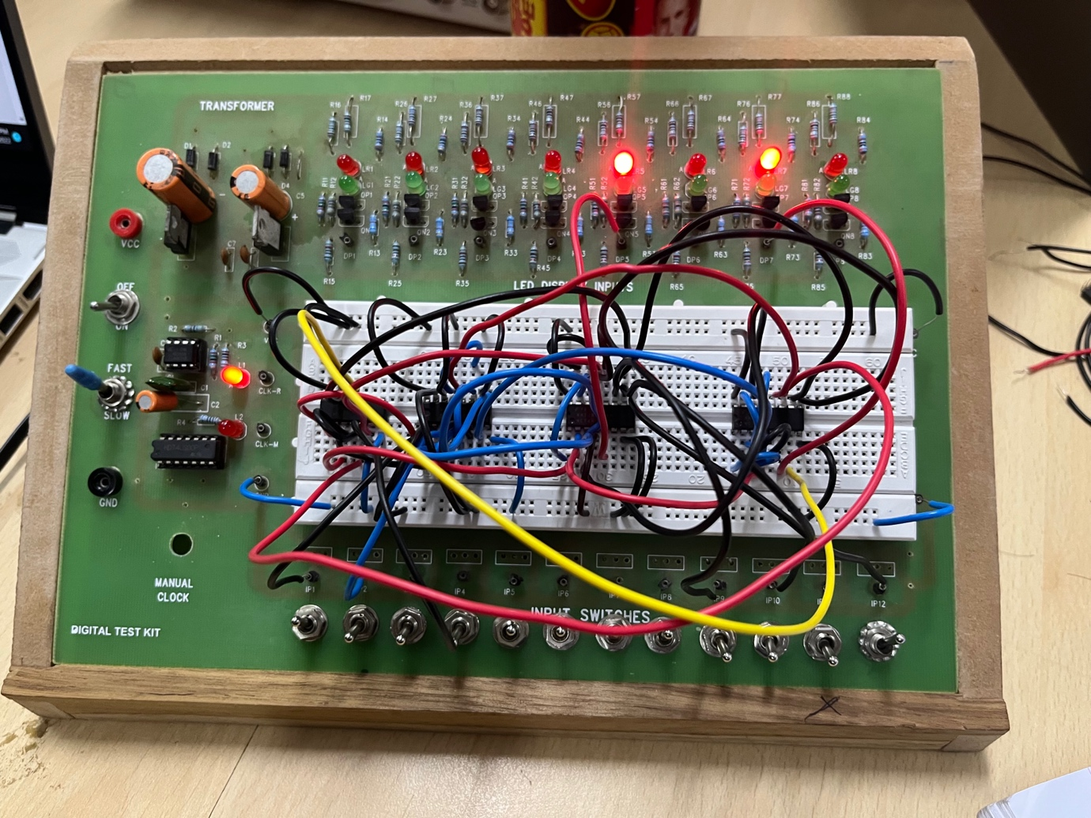

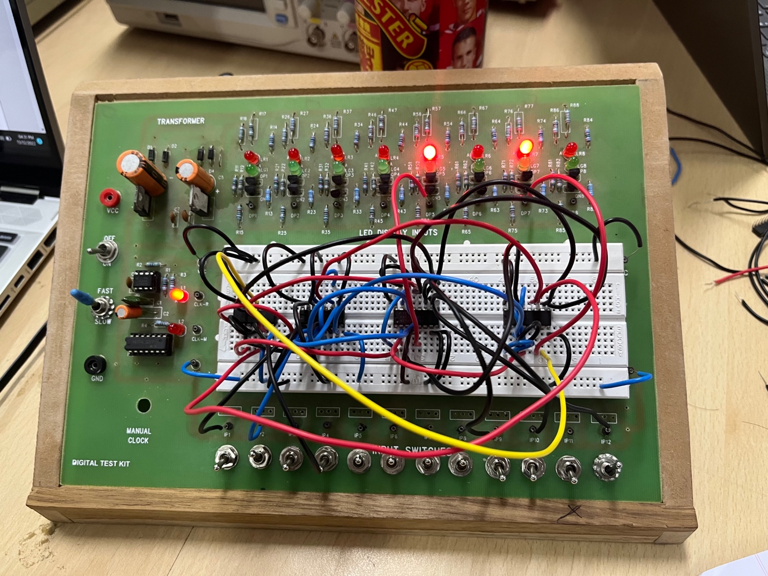

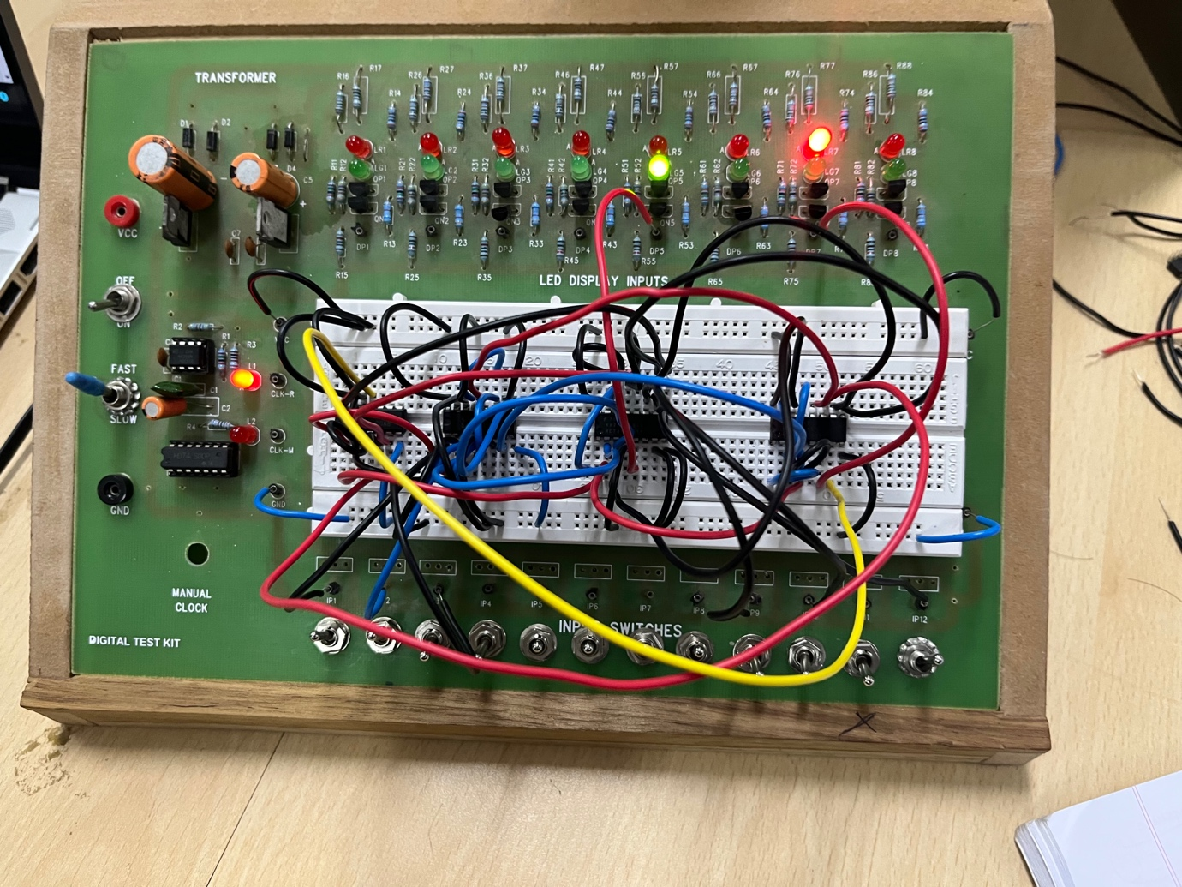

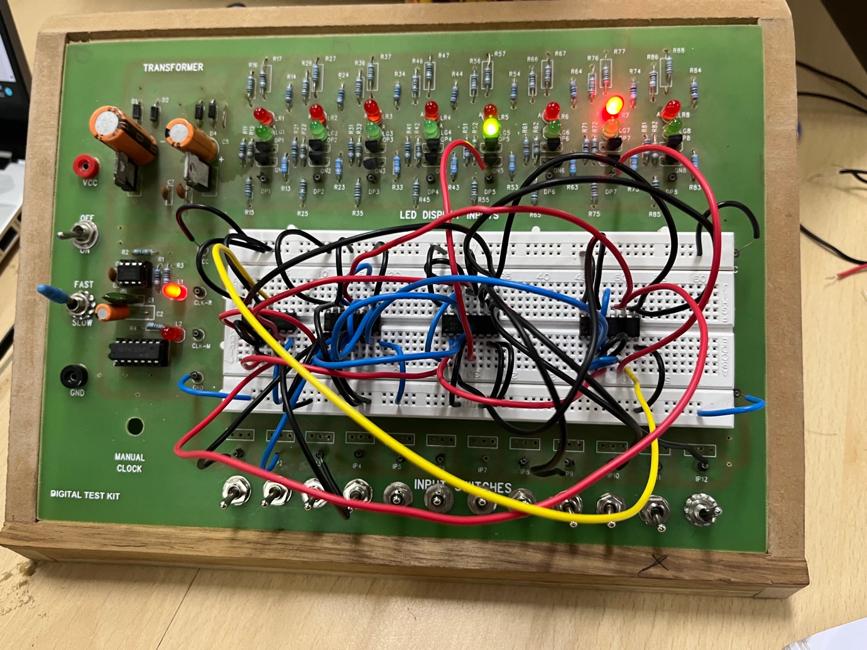

CONCLUSION:-

This in this way we can make an ALU with the above functions using 8:1 MUXs and 2:1 MUXs.